TEXT ANALYSIS

[nltk_data] Downloading package punkt to
[nltk_data] C:\Users\mahac\AppData\Roaming\nltk_data...
[nltk_data] Package punkt is already up-to-date!
[nltk_data] Downloading package stopwords to
[nltk_data] C:\Users\mahac\AppData\Roaming\nltk_data...
[nltk_data] Package stopwords is already up-to-date!
[nltk_data] Downloading package wordnet to
[nltk_data] C:\Users\mahac\AppData\Roaming\nltk_data...
[nltk_data] Package wordnet is already up-to-date!
[nltk_data] Downloading package averaged_perceptron_tagger to
[nltk_data] C:\Users\mahac\AppData\Roaming\nltk_data...
[nltk_data] Package averaged_perceptron_tagger is already up-to-
[nltk_data] date!
[nltk_data] Downloading package punkt_tab to
[nltk_data] C:\Users\mahac\AppData\Roaming\nltk_data...
[nltk_data] Package punkt_tab is already up-to-date!
Looking for papers in: C:\Users\mahac\Desktop\pdf_files
Found 67 PDF files in folder
Processing: 10.pdf... ✓ Loaded successfully
Processing: 11.pdf... ✓ Loaded successfully
Processing: 12.pdf... ✓ Loaded successfully
Processing: 13.pdf... ✓ Loaded successfully
Processing: 14.pdf... ✓ Loaded successfully
Processing: 15.pdf... ✓ Loaded successfully
Processing: 16.pdf... ✓ Loaded successfully
Processing: 17.pdf... ✓ Loaded successfully
Processing: 18.pdf... ✓ Loaded successfully
Processing: 19.pdf... ✓ Loaded successfully
Processing: 20.pdf... ✓ Loaded successfully
Processing: 21.pdf... ✓ Loaded successfully
Processing: 22.pdf... ✓ Loaded successfully
Processing: 24.pdf... ✓ Loaded successfully
Processing: 25.pdf... ✓ Loaded successfully
Processing: 26.pdf... ✓ Loaded successfully
Processing: 27.pdf... ✓ Loaded successfully
Processing: 28.pdf... ✓ Loaded successfully
Processing: 29.pdf... ✓ Loaded successfully
Processing: 3.pdf... ✓ Loaded successfully
Processing: 30.pdf... ✓ Loaded successfully
Processing: 31.pdf... ✓ Loaded successfully
Processing: 32.pdf... ✓ Loaded successfully
Processing: 33.pdf... ✓ Loaded successfully
Processing: 34.pdf... ✓ Loaded successfully
Processing: 35.pdf... ✓ Loaded successfully
Processing: 36.pdf... ✓ Loaded successfully
Processing: 37.pdf... ✓ Loaded successfully
Processing: 38.pdf... ✓ Loaded successfully
Processing: 39.pdf... ✓ Loaded successfully
Processing: 4.pdf... ✓ Loaded successfully
Processing: 40.pdf... ✓ Loaded successfully
Processing: 41.pdf... ✓ Loaded successfully
Processing: 42.pdf... ✓ Loaded successfully
Processing: 43.pdf... ✓ Loaded successfully
Processing: 44.pdf... ✓ Loaded successfully
Processing: 45.pdf... ✓ Loaded successfully
Processing: 47.pdf... ✓ Loaded successfully
Processing: 48.pdf... ✓ Loaded successfully
Processing: 49.pdf... ✓ Loaded successfully
Processing: 50.pdf... ✓ Loaded successfully
Processing: 51.pdf... ✓ Loaded successfully
Processing: 52.pdf... ✓ Loaded successfully
Processing: 53.pdf... ✓ Loaded successfully
Processing: 54.pdf... ✓ Loaded successfully
Processing: 55.pdf... ✓ Loaded successfully
Processing: 56.pdf... ✓ Loaded successfully
Processing: 58.pdf... ✓ Loaded successfully
Processing: 59.pdf... ✓ Loaded successfully
Processing: 6.pdf... ✓ Loaded successfully
Processing: 60.pdf... ✓ Loaded successfully
Processing: 61.pdf... ✓ Loaded successfully
Processing: 62.pdf... ✓ Loaded successfully
Processing: 63.pdf... ✓ Loaded successfully
Processing: 64.pdf... ✓ Loaded successfully
Processing: 65.pdf... ✓ Loaded successfully
Processing: 66.pdf... ✓ Loaded successfully
Processing: 67.pdf... ✓ Loaded successfully
Processing: 68.pdf... ✓ Loaded successfully
Processing: 69.pdf... ✓ Loaded successfully
Processing: 70.pdf... ✓ Loaded successfully
Processing: 71.pdf... ✓ Loaded successfully
Processing: 72.pdf... ✓ Loaded successfully
Processing: 73.pdf... ✓ Loaded successfully
Processing: 74.pdf... ✓ Loaded successfully
Processing: 75.pdf... ✓ Loaded successfully
Processing: 8.pdf... ✓ Loaded successfully

Successfully loaded: 67 out of 67 papers
============================================================
RESEARCH PAPER THEME ANALYSIS
============================================================
Preprocessing papers...
Preprocessing completed! 67 papers ready for analysis.

1. TOP KEYWORDS ANALYSIS
------------------------------
chatgpt: 0.1127
data: 0.0800
http: 0.0721
customer: 0.0711
technology: 0.0696
genai: 0.0696
model: 0.0675
service: 0.0642
marketing: 0.0631
human: 0.0611
doi: 0.0595
generative: 0.0577
consumer: 0.0546
use: 0.0523
doi org: 0.0522

2. LDA TOPIC MODELING
------------------------------
Topic 1: chatgpt, data, model, http, generative, human, technology, use
Topic 2: consumer, brand, effect, http, genai, advertising, diversity, marketing
Topic 3: proposal, liability, act, article, system, law, risk, model
Topic 4: technology, doi, chatgpt, http, gai, management, customer, org
Topic 5: customer, review, experience, place, marketing, emotion, feedback, topic

3. NMF TOPIC MODELING
------------------------------
Topic 1: service, customer, data, technology, gai, human, management, model
Topic 2: genai, paradox, customer, brand, marketing, consumer, human, service
Topic 3: chatgpt, tourism, marketing, student, hospitality, use, education, technology
Topic 4: advertising, diversity, consumer, brand, doi org, http doi, diversity representation, org
Topic 5: llm, model, text, data, lca, task, language, http

4. GENERATING VISUALIZATIONS...
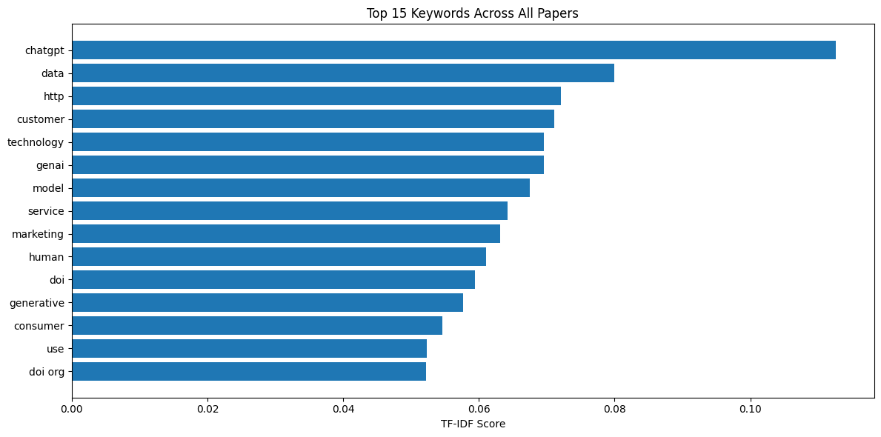

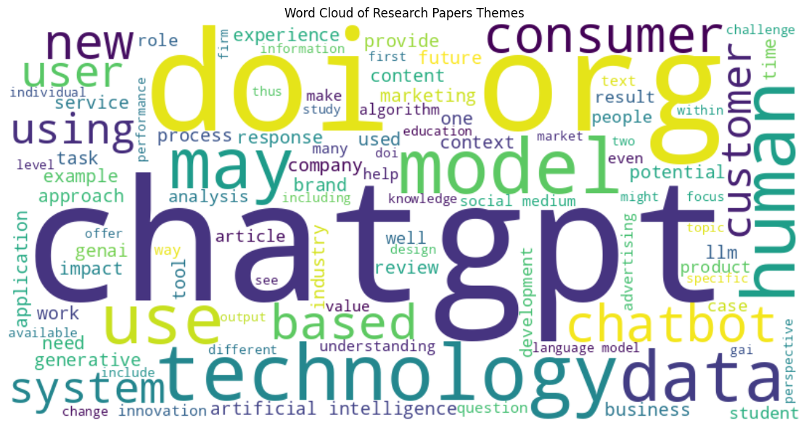

============================================================
ANALYSIS SUMMARY
============================================================
Total papers analyzed: 67
Papers successfully processed: 67
Main themes identified: 5
Top keywords found: 20

